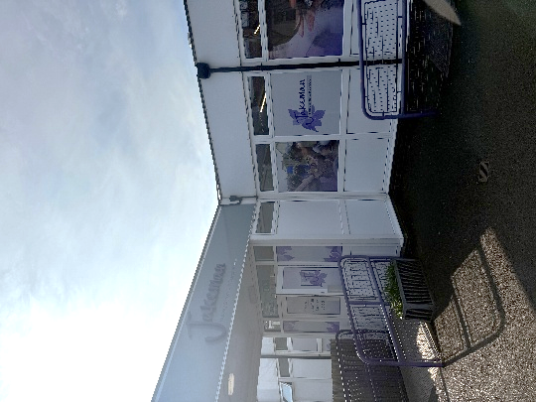

Jakeman Nursery School Room Hire Charges and Booking Form
If you would like to make a general enquiry first, please email enquiry@jakeman.bham.sch.uk
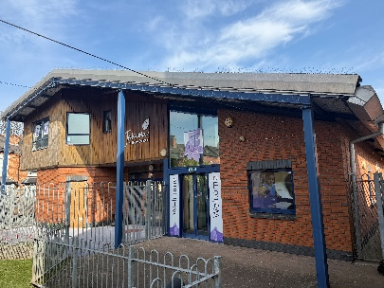
Details of person booking the room
Name
Role
Organisation and Organisation Address
Contact Number
Email Address
Date of Event
Title Of Meeting/Training/Visit
Name of Trainer/Presenter/Visit Leader

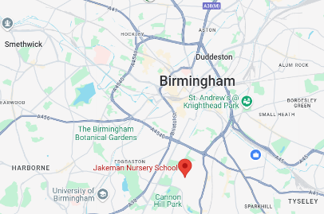
Cancellation Policy
Cancellation received less than 48 hours prior to booking date | 100% of Total Fee
Cancellation received in writing less than 5 working days prior to booking date | 50% of Total Fee
Cancellation received in writing 10 working days prior to booking date | No Charge
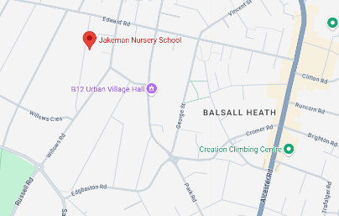
Special Provisions/requirements
Details

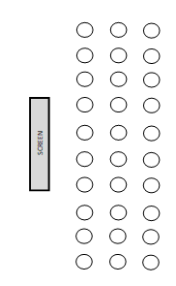
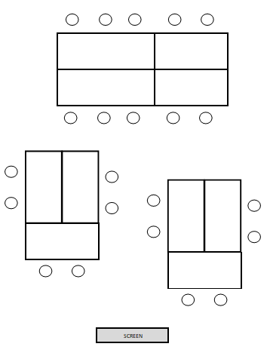
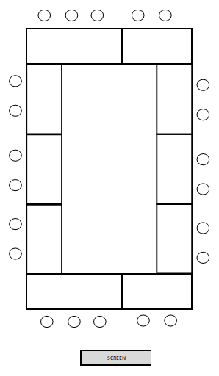
Large Meeting/Training Room Layout Choices
Banquet – up to 22

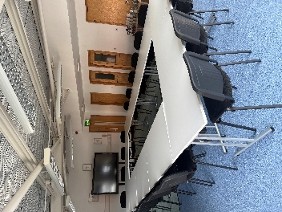
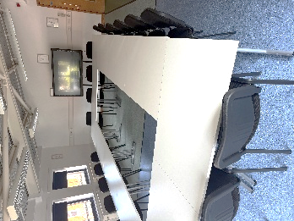
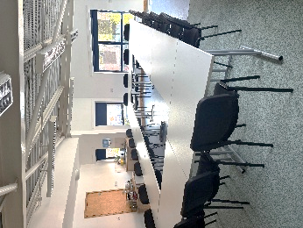
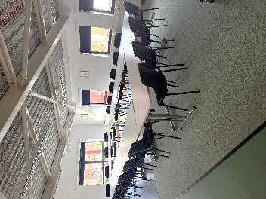
Theatre – up to 30

Boardroom – up to 26
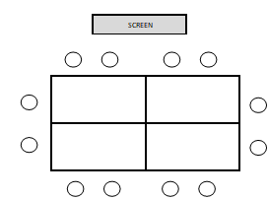
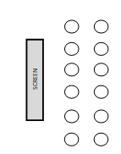
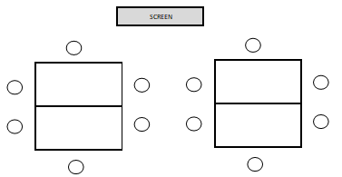
Small Meeting/Training Room Layout Choices
Theatre - up to 12

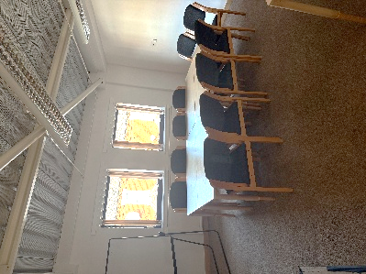
Banquet – up to 12

Boardroom – up to 12

Additional information:
- Parking in the Jakeman carpark is first come, first served
- There is parking on residential streets close to the Nursery
- Training room is located in the 2 storey-building, on the left hand side of the carpark
- All attendees must sign in and out with the facilitator/organisation
- Mobile phone use is not permitted on the ground floor of the building
- Please refer to Fire Evacuation Procedures shared at point of booking confirmation. The facilitator shares this information with attendees.
- The training/meeting room is located on the first floor. Please note, the lift is currently out of use.
- Toilet facilities are available on both ground and first floors.
- Should any of the attendees have any concerns of a child protection or safeguarding nature, please ask at reception in the main nursery building for the DSL on duty.
ROOM | ROOM  CAPACITY | Charges | Select:  Full day/ AM/ PM /  # of hours | Room Set up:  (Please highlight or tick) | Date(s) Required:
Large Training Room  (Interactive screen) | Max 30 | £150 per full day**  £80 per half day*  £25 per hour |  | Boardroom  Banquet  Horseshoe 1  Horseshoe 2  Theatre  Other:
Small Training Room  (No Interactive Screen) | Max 10/12 | £70 per full day**  £38 per half day*  £12 per hour |  | Boardroom  Banquet  Theatre  Other:

*HALF DAY BOOKING - 8AM-12NOON OR 12:30PM -4:30PM ** FULL DAY BOOKING - 8AM-4:00PM
Name
Role
Address
Contact Number
Email Address
Total Cost
Purchase Order Number
Invoice Sent date & by whom
Payment Received by & date
ALL BOOKING FORMS TO BE EMAILED TO AMNA BIBI – a.bibi@jakeman.bham.sch.uk
Invoice to be sent to:

